**Name: Kanak Agrawal**

**Email:** [**Kanakagrawal2001@gmail.com**](mailto:Kanakagrawal2001@gmail.com)

**Date: 09-02-2024**

**Day-14 Assignment (Pyspark)**

**Question: Manipulating, Dropping, Sorting, Aggregations, Joins**

1. **Manipulating**

* **Group By and Aggregate Functions**

**Code:**

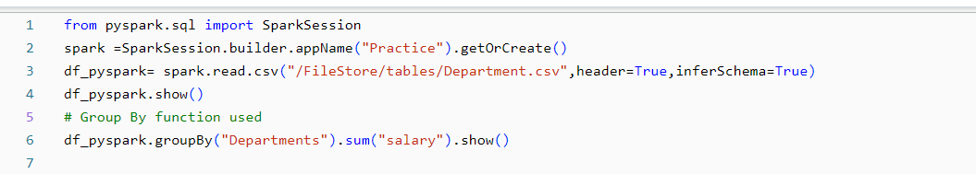

**Ouput:**

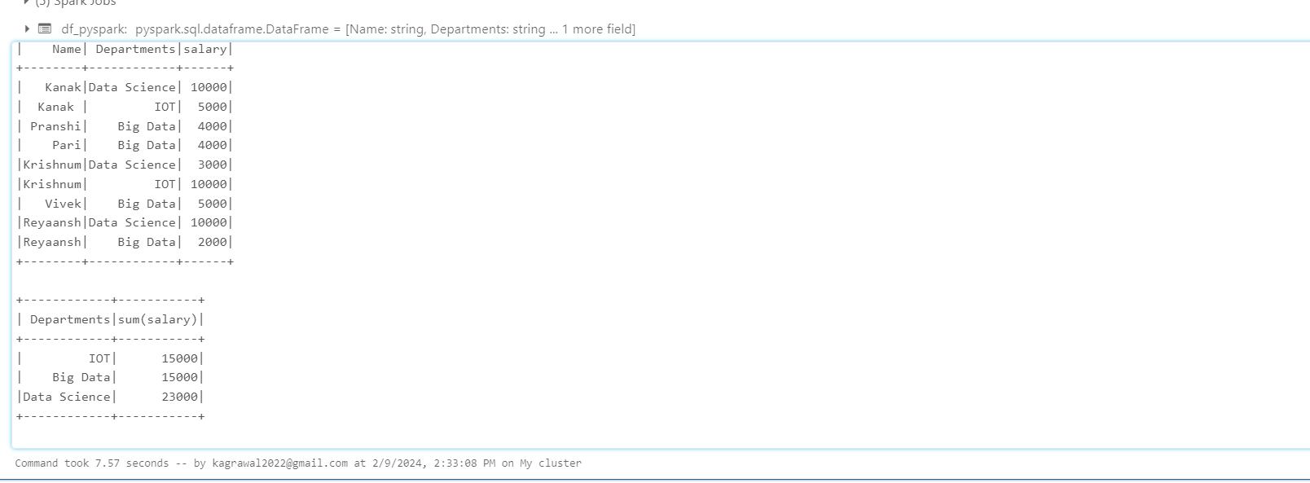

* **Aggregate Function**

1. **Minimum**

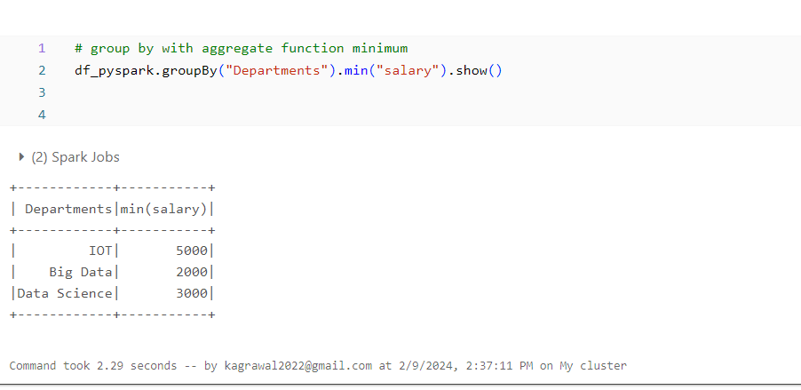

1. **Maximum**

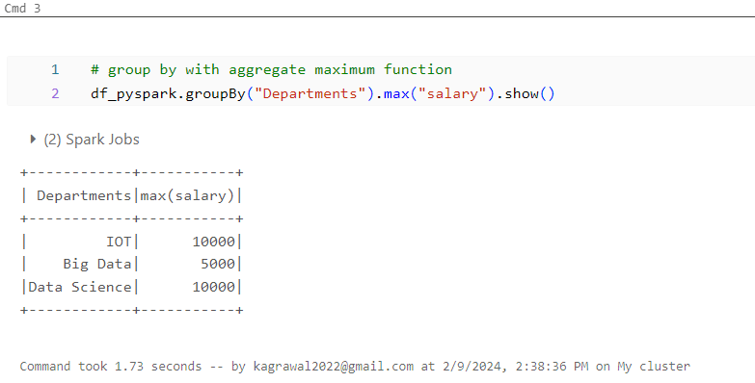

1. **Average**

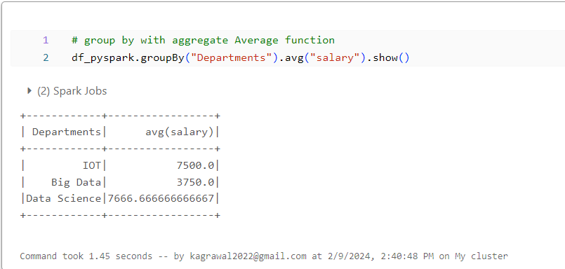

1. **Mean**

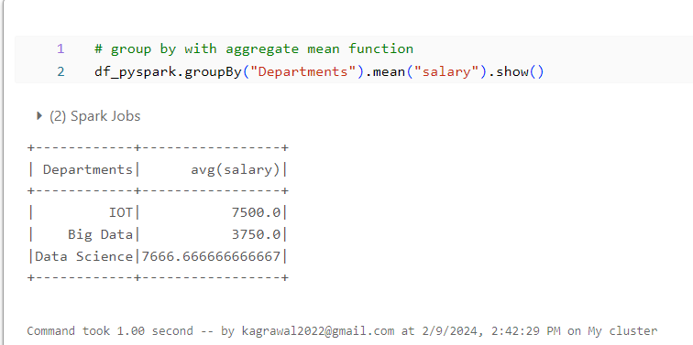

1. **Count**

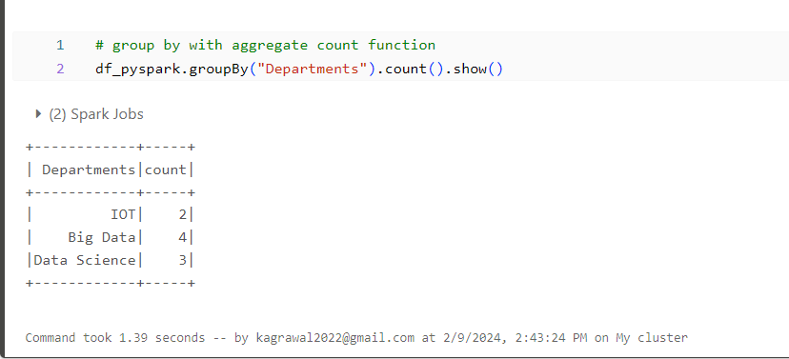

1. **Sum**

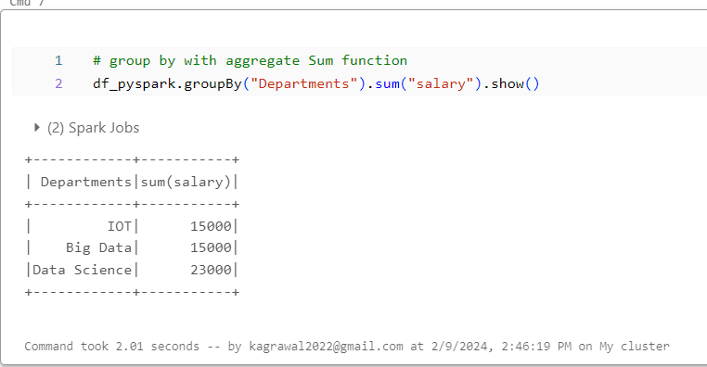

1. **Agg**

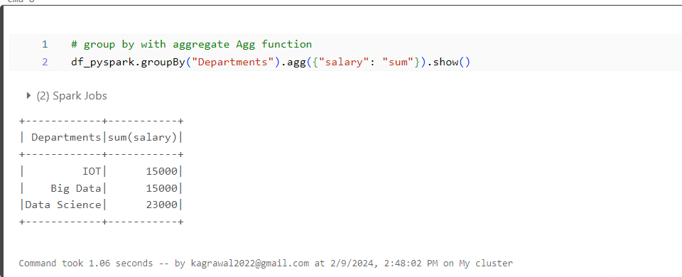

1. **Pivot**

This function is used to convert one column into multiple column(transpose of row to column).

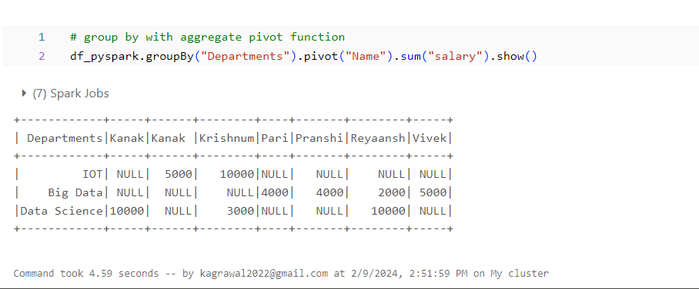

1. **Dropping**

* **Dropping rows based on null values**

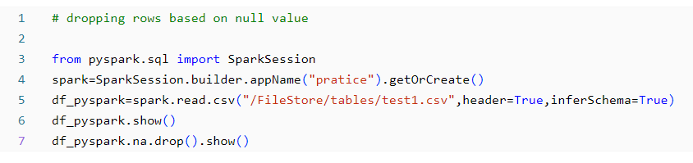

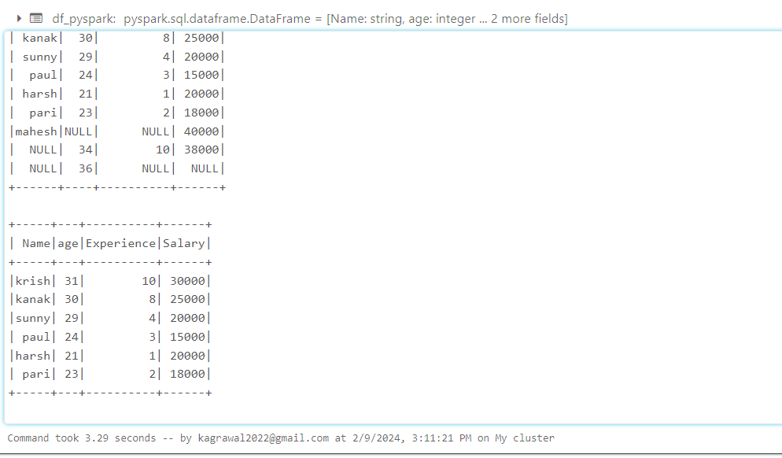

* **Dropping rows based on “how”**

If all values in a row are null then

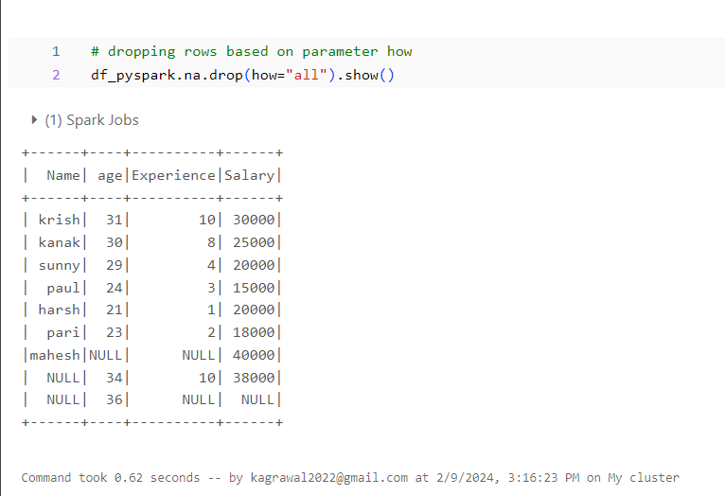

* **Dropping rows based on “thresh”**

Atleast 2 non null values should be present

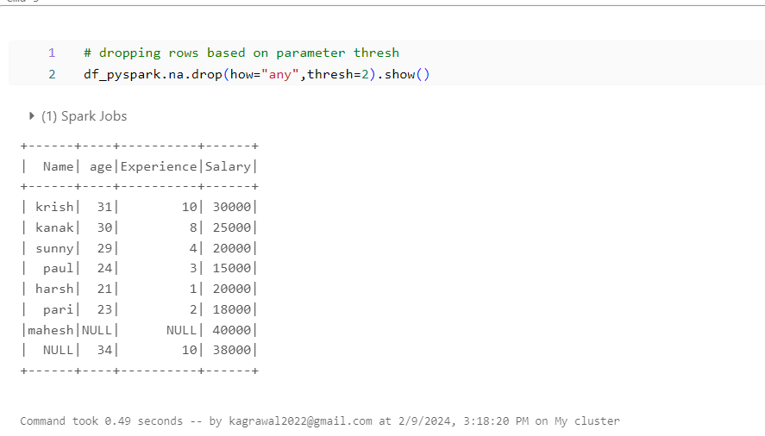

* **Dropping rows based on “subset”**

Only in that column rows get deleted

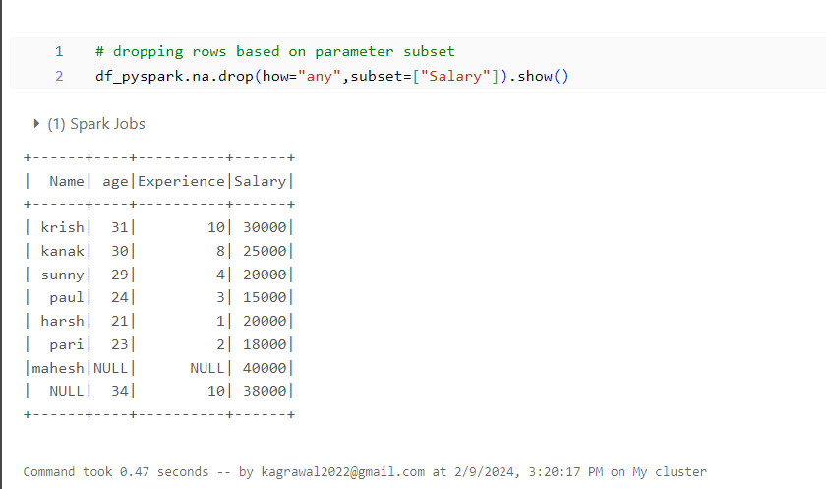

1. **Sorting and order by**

* **Sorting based on single column**

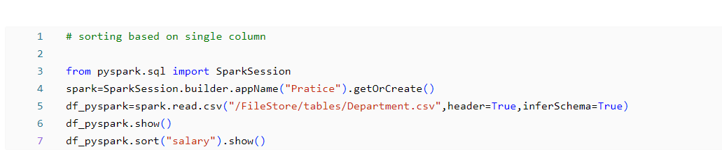

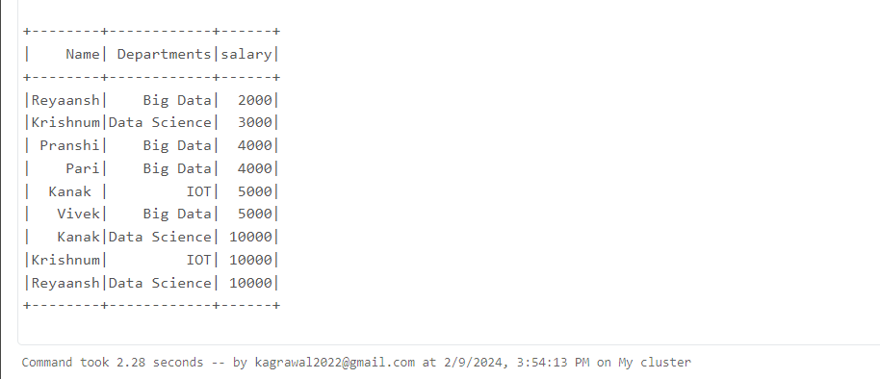

* **Sorting based on descending order**

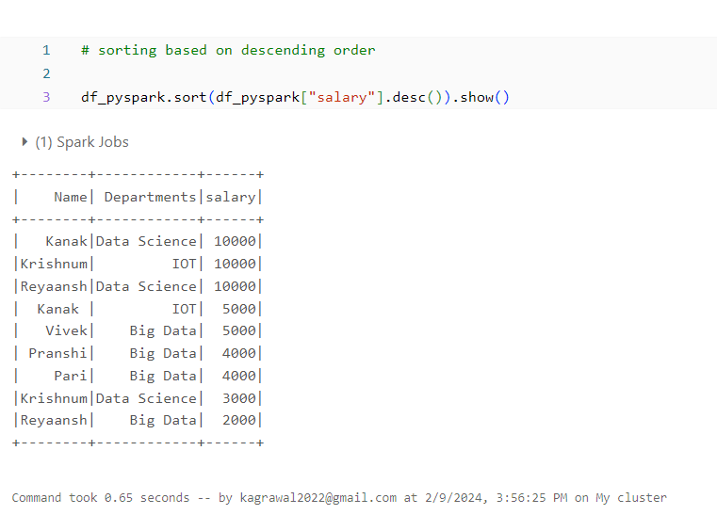

* **Sorting based on Ascending order**

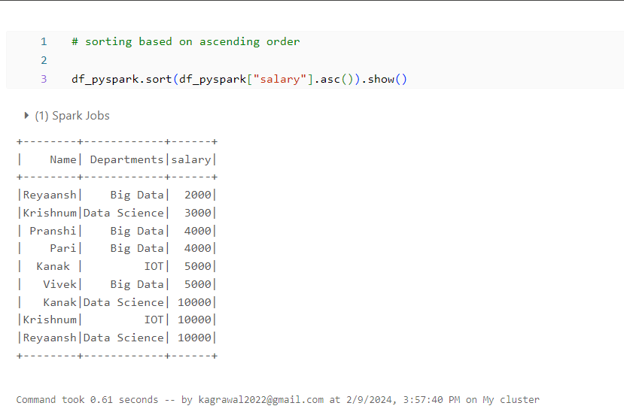

* **Sorting based on first column and then second column**

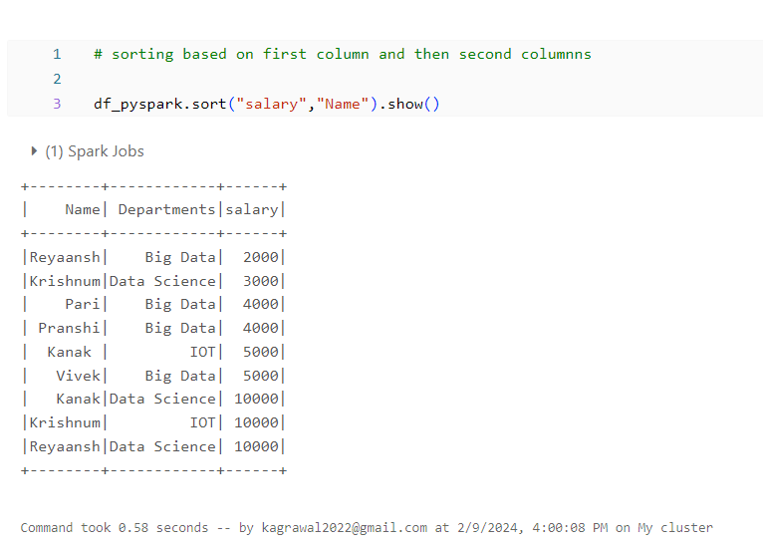

* **Order By**

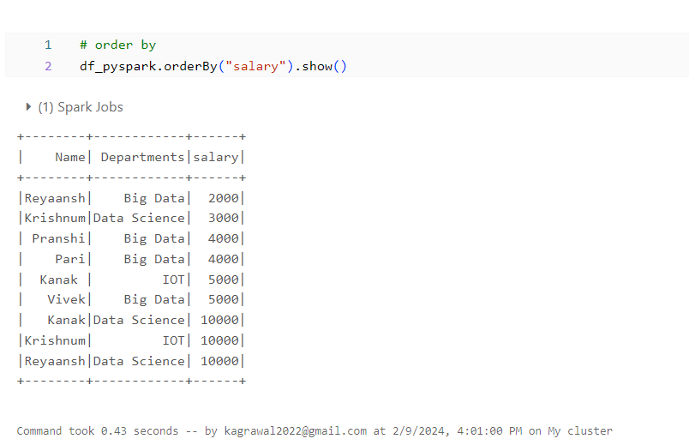

1. **Joins**

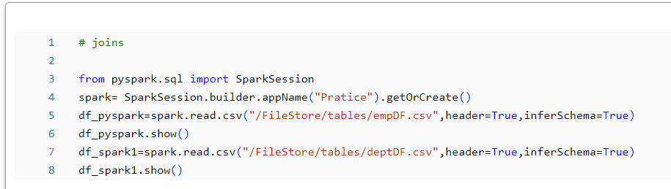

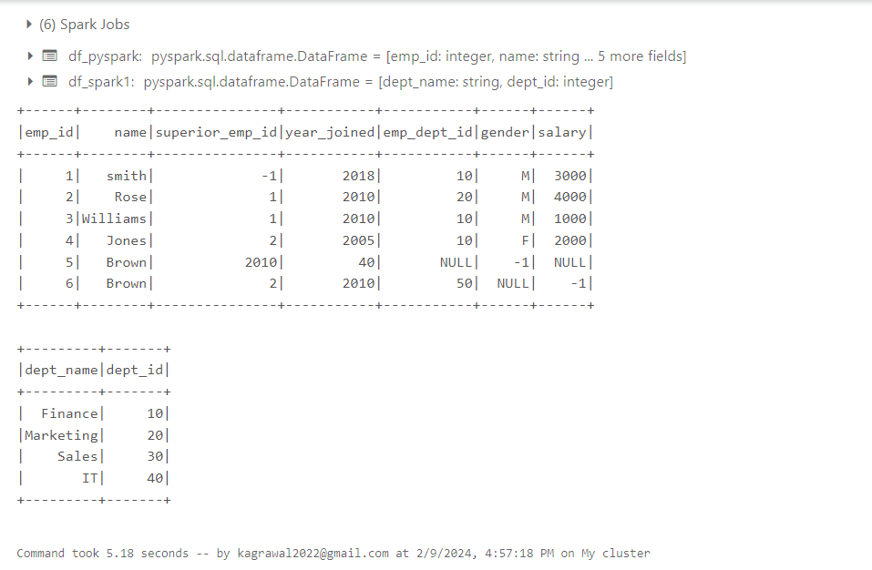

1. **Inner Join**

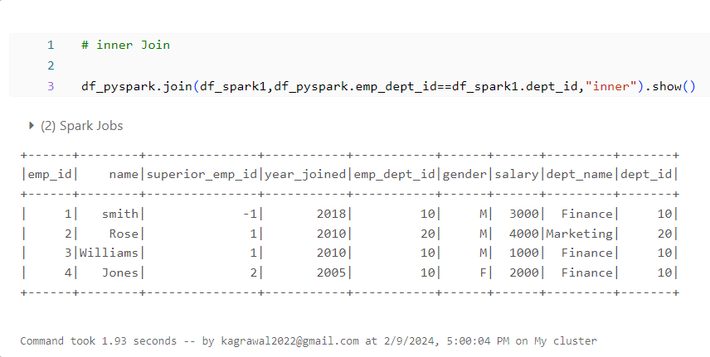

1. **Outer join**

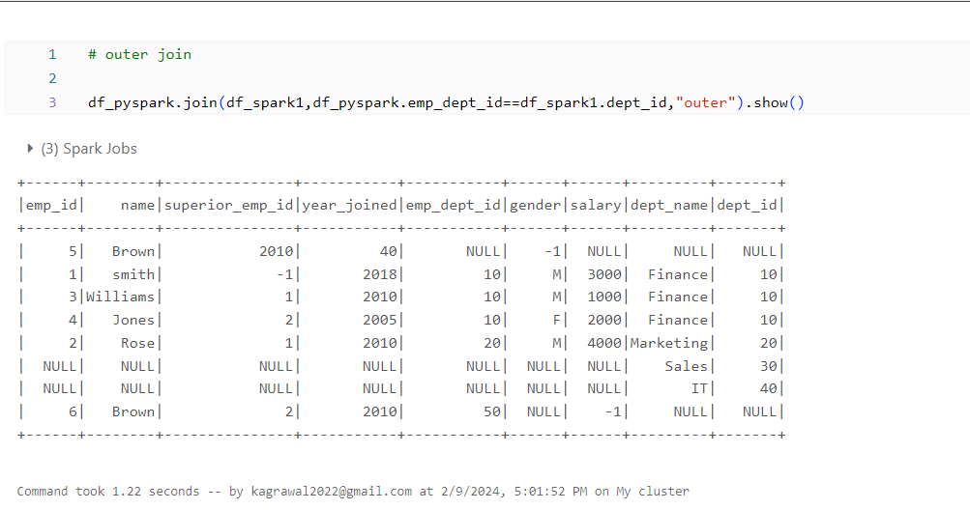

1. **Left Join**

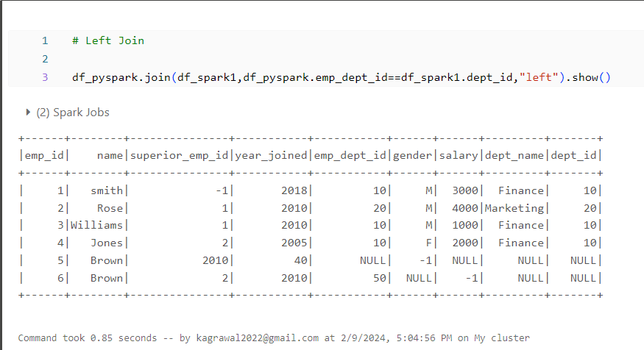

1. **Right Join**

